ECS174 Seunghyup Alex Oh (916201993)

**Problem Set#1**

I. Short answer problems [24 points]

1. Give an example of how one can exploit the associative property of convolution to more efficiently filter an image.

Exploiting the associative property of convolution enables convolving an image with one filter and another filter after equivalent to convolving the image with a convolved result of those two filters – which means that 2D filter can be shown as a convolution of two 1D filters. Convolving the image with the two separate filters are computationally more efficient than filtering the image with the convolved result of two filters. This can be demonstrated with the associative equation, f * (g * h) = (f * g) * h (Filter f and g, an image h). For example, computing f * (g * h) = f * (1 X 3 * h) = (3 X 1) * (g * h) takes 3 multiplication for each filter to convolve the image and total is 6 multiplication which is 2K (size of convolved filter of two filters is K X K). And computing (f * g) * h = (3 X 1) * (1 X 3) * h = (3 X 3) * h takes total 9 multiplication which is K^2.

2. This is the input image: [1 0 0 1 1 0 0 1]. What is the result of dilation with a structuring element [1 1 1]?

Result: [1 1 1 1 1 1 1 1]

3. Describe a possible flaw in the use of additive Gaussian noise to represent image noise.

Not all types of image noises can be represented with the use of additive Gaussian noise. The Gaussian noise is statistical noise that has a normal distribution (=Gaussian-distribution) probability density function which means that the values that the noise can take on are Gaussian-distributed. Thus, the additive Gaussian noise does not work effectively on the images with non-normally distributed noise variation.

4. Design a method that takes video data from a camera perched above a conveyor belt at an automotive equipment manufacturer and reports any flaws in the assembly of a part. Your response should be a list of concise, specific steps, and should incorporate several techniques covered in class thus far. Specify any important assumptions your method makes.

Assumption:

* The machine (using this method) already knows what the part should normally look like by learning from sufficient sets of image.
* The parts are carrying by the conveyor belt in same speed.
* Every part itself can be distinguished from its surrounding to optimize, to reduce the noise and has uniform size.
* The parts do not overlap on the camera window.

Steps: Edge analysis method

1. By using Canny edge detection method, detect the target part, edges, with noise suppressed at the same time.

* Capture the image on the conveyor belt and filter image with derivative of Gaussian.
* Find magnitude and orientation of gradient.
* Use non-maximum suppression and linking and thresholding (hysteresis thresholding) to find continued edges, curves/contours.

1. Use chamfer distance to compare the current image to the flawless image (which we already know from the assumption).
2. If there occurs mismatching between those two images (=If the current image of the part does not match with the flawless image), the part has a flaw.

II. Programming problem: content-aware image resizing [76 points]

1.

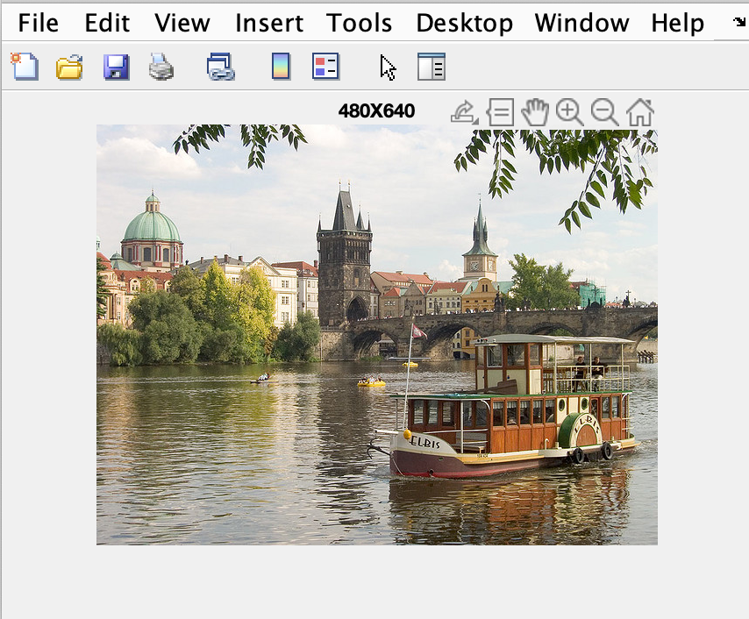

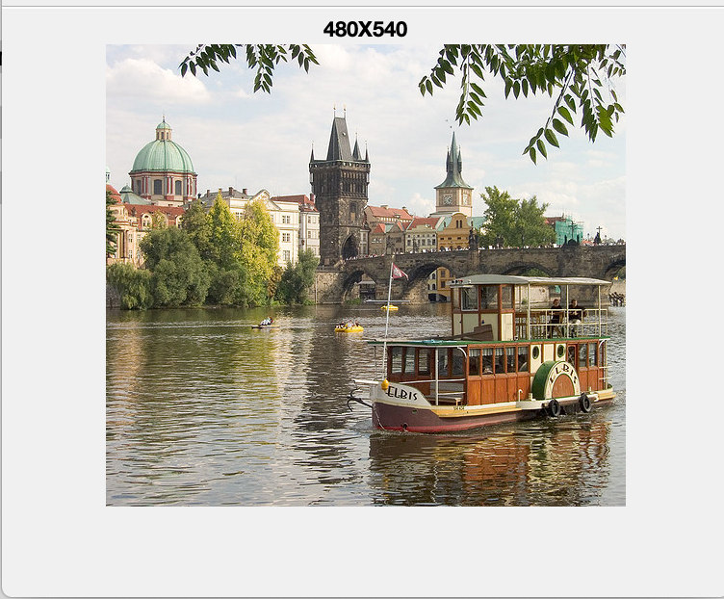

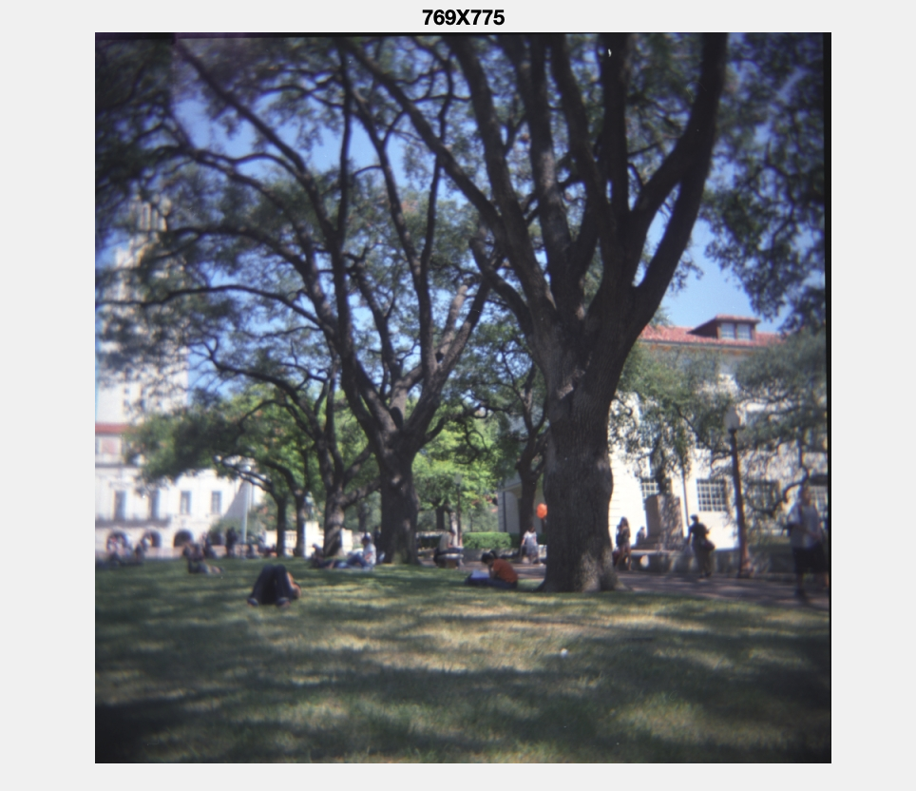

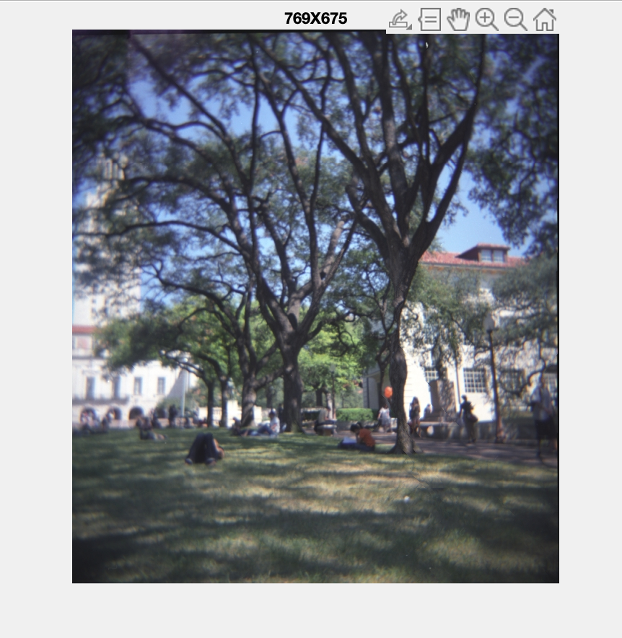

2.

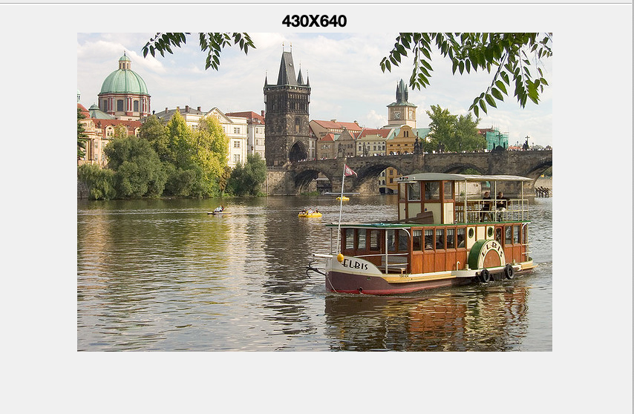

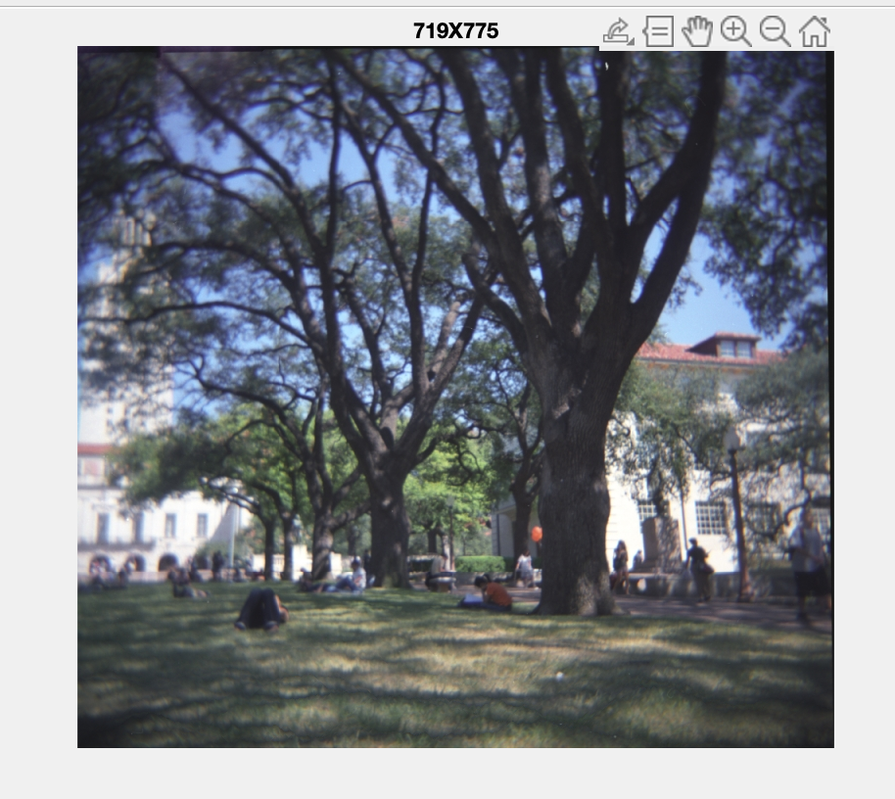

3. From the energy function, we first transform the image to grayscale image. Then slide it through the ‘sobel’ filter and calculate the edge strength. Through this steps I achieve to differentiate the high edge which has relatively high energy from lower energy edges. Lastly, on the process of calculating the edge strength will outline the edges.

Different directions, horizontal and vertical directions, displays and demonstrates that the energies are accumulated and summed up as we proceed through rightwards in horizontal direction and downwards in vertical on the energy map.

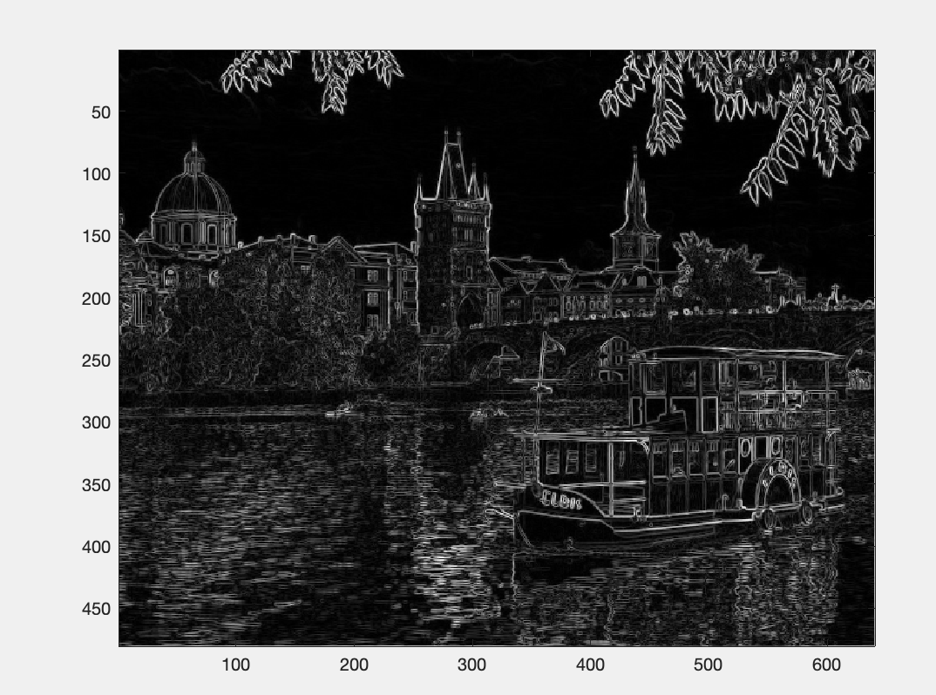

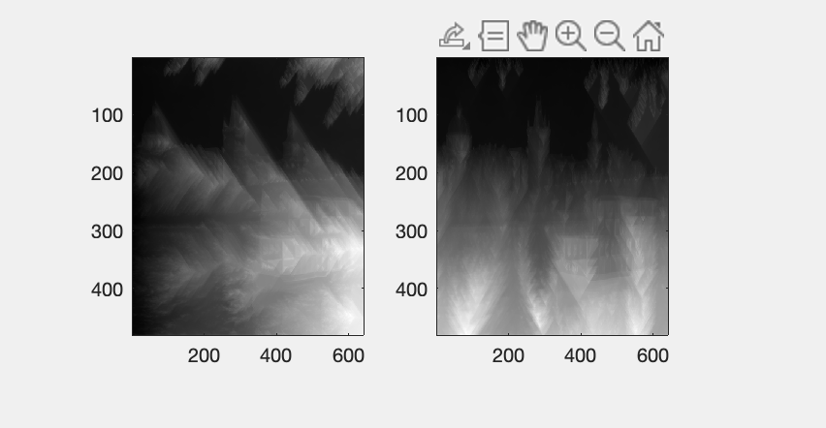

Horizontal - Vertical

4. Each horizontal and vertical seam in the cumulative energy map of the input image is the least energy representation which means that along the line, it is the least distinguishable and has least contrast. Hence, these seams are optimal seams to cut out from this image.

(a) Horizontal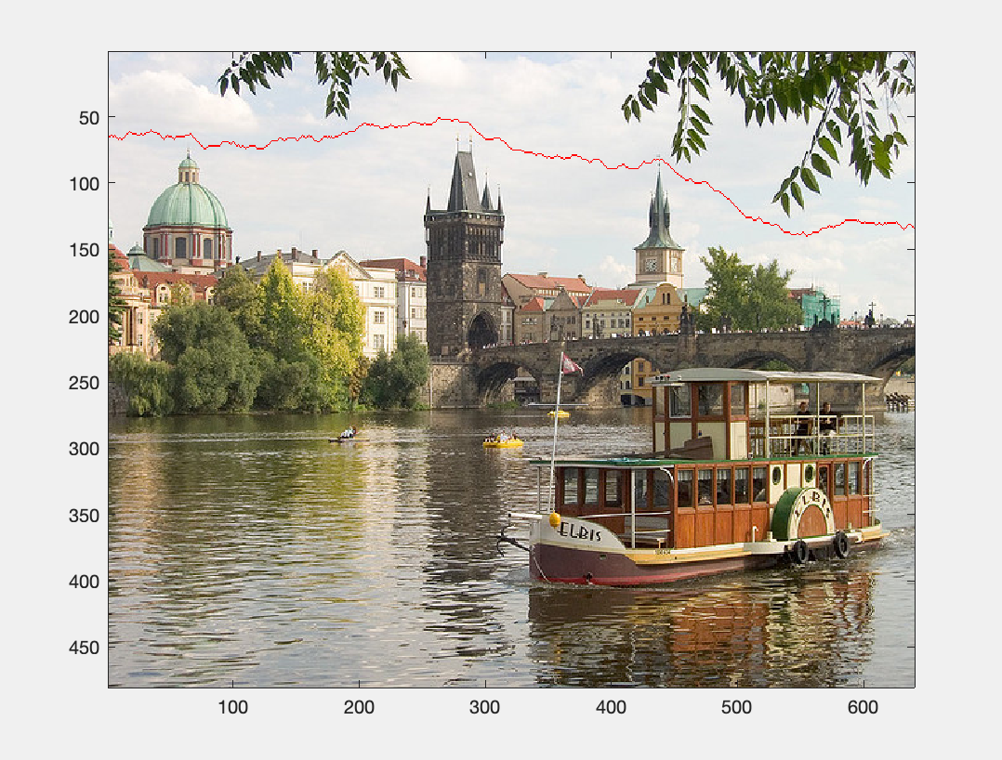

(b) Vertical

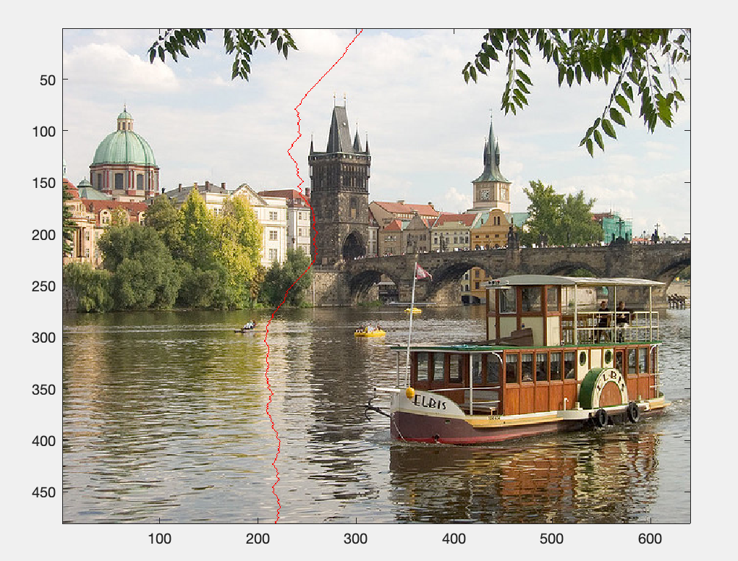

5. Former energy function filters the image through ‘Sobel’ filter. This image instead uses ‘Prewitt’ filter. You will be able to see there is almost no difference finding both directional seams since these two filters are pretty similar except that the Sobel filter’s coefficients of masks are not fixed so that it can be adjusted according to each requirement.

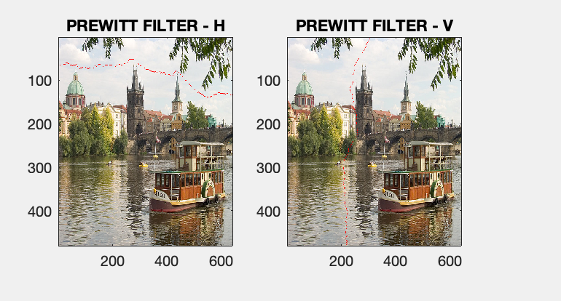

6.

(a) – (c)

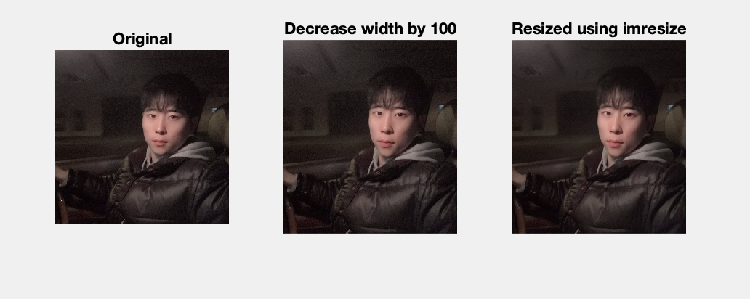

(d) Original Image Size: 960 X 960

Reduced Image Size by 100 Width: 860 X 960

Reduced Image Size using imresize: 430 X 480

(e) To practice both enlargements and removals that were used through out the seam carving, this project, has basically same approach but just the differences occur in whether to erase the minimum value of seam or to add it to the image. We first convert image to grayscale and find the calculate the edge strength so that we can find out the least energy-valued seam. And by whether erasing out or adding the seam achieves enlargements and removals.

(f) Three images display original image and reduced size image using our manual function and MATLAB resizing built in function. As you can see from the picture, he second picture using decrease_width by 100px and it got shrunken. The third picture is resized by the method of imresize with scale of 0.5; hence, the image is half times the size of the original picture.